
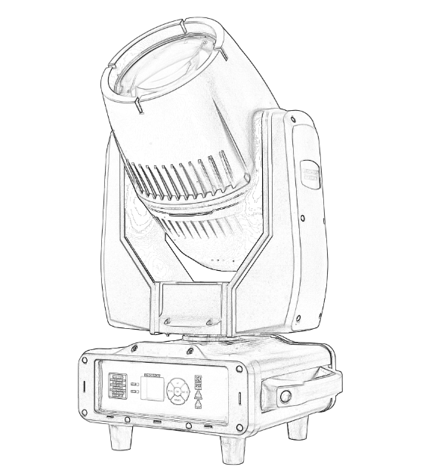
User manual

MINI BEAM 350W IP65
Please read the instructions carefully before use

TABLE OF CONTENTS
- Safety Instructions………………………………………………………………………………3
- Technical Specifications…………………………………………………………………………4
- Control Menu ……………………………………………………………………………………5-7
- DMX Channel ……………………………………………………………………………………8-10
- Trouble Shooting…………………………………………………………………………………10
- Fixture Cleaning………………………………………………………… ………………………10

STATEMENT
The product has well capability and intact packing when leave factory. All of the user should comply with warning item and manual, any misuse cause of the damages are not included in our guarantee, and also can not be responsible for any malfunction & problem owing to ignore the manual.

1.Safety Instructions
Please keep this User Guide for future consultation. If you sell the unit to another user, be sure that they also receive this instruction booklet.
•Unpack and check carefully there is no transportation damage before using the unit.
•Before operating, ensure that the voltage and frequency of power supply match the power requirements of the unit.
•It’s important to ground the yellow/green conductor to earth in order to avoid electric shock.
•The unit is for indoor use only. Use only in a dry location.
•The unit must be installed in a location with adequate ventilation, at least 50cm from adjacent surfaces. Be sure that no ventilation slots are blocked.
•Disconnect main power before replacement or servicing.
•Make sure there are no flammable materials close to the unit while operating as it is fire hazard.
•Use safety cable when fixes this unit. DO NOT handle the unit by taking its head only, but always by taking its base.
•Maximum ambient temperature is Ta: 40℃. DO NOT operate it where the temperature is higher than this Unit surface temperature may reach up to 85℃. DO NOT touch the housing bare-hand during its operation. Turn off the power and allow about 15 minutes for the unit to cool down before replacing or serving.
•the event of serious operating problem, stop using the unit immediately.Never try to repair the unit by yourself. Repairs carried out by unskilled people can lead to damage or malfunction. Please contact the nearest authorized technical assistance center. Always use the same type spare parts.
•DO NOT touch any wire during operation as high voltage might be causing electric shock.
Warning:
•To prevent or reduce the risk of electrical shock or fire, do not expose the unit to rain or moisture.
•The housing, the lenses, or the ultraviolet filter must be replaced if they are visibly damaged.
Caution:
•There are no user serviceable parts inside the unit. DO NOT open the housing or attempt any repairs yourself. In the unlikely event your unit may require service, please contact your nearest dealer.
Installation:
•The unit should be mounted via its screw holes on the bracket. Always ensure that the unit is firmly fixed to avoid vibration and slipping while operating. And make sure that the structure to which you are attaching the unit is secure and is able to support a weight of 10 times of the unit’s weight. Also always use a safety cable that can hold 12 times of the weight of the unit when installing the fixture.
•The equipment must be fixed by professionals. And it must be fixed at a place where is out of the touch of people.

2.Technical Specifications
Optics:
Light Source:350W beam
Beam angle: 1.8°
Power:350W
IP rate : IP65
Input voltage:AC100-240V 50-60HZ
Pan movement:540° (16bit )
Tilt movement:270°(16bit)
Color:13+1+colorful rainbow effect+ frost function
Fixed gobo: 13 fixed patterns + white light
Prism: 8 prisms / 8+16 prisms stacked and rotatable, macro function
Dimming system: 0-100% linear adjustment
DMX channels: 16 CH

Features:
XY motor: three-phase electric drive, powerful, faster, more stable and quieter
Control mode: DMX 512, self-propelled, master-slave self-propelled
Support RDM function, built-in program: built-in multiple effect programs
NW:20.7KGS

3.Control Menu

Control instructions
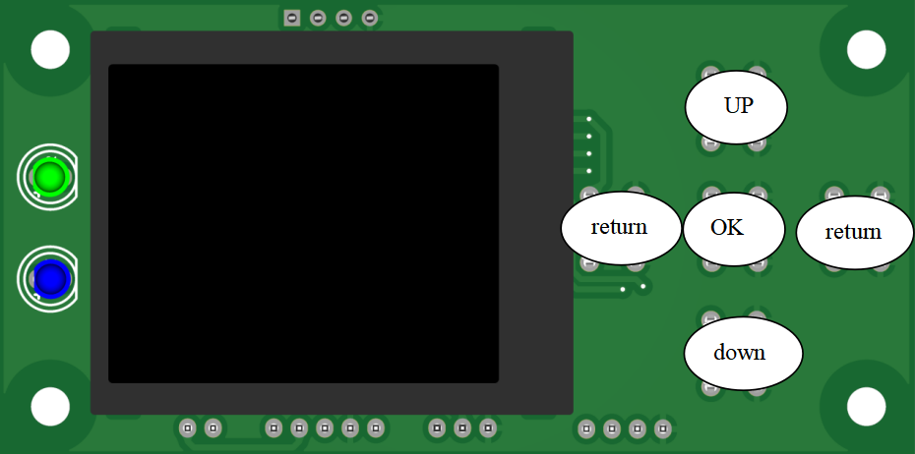

1)The function of the 'return' button is to return to the previous interface and exit the function
2)The function of the 'up' button is to select the previous item or increase the value by pressing
for 2 seconds to quickly increase it
3)The function of the "down" button is to select the next item or decrease the value by pressing
for 2 seconds to quickly decrease it
4）The functions of the "OK" button are: confirm save, execute functions, start editing, and
exit editing

Interface Description
Two LED indicators on the left
Green - (DMA signal indicator light)
Blue --- (constantly on (self running voice control of the host) flashing (error indication))
The three buttons in the upper right corner are used for language switching and screen rotation.
The sub interfaces corresponding to the four buttons in the bottom row are introduced below.

Setting interface
Option | illustrate
Mode | DMX | Slave state: receiving DMX signals from the control console or host
Mode | AUTO | Host status: automatically running and sending a DMX signal to the slave
Mode | Sound | Host status: Voice controlled operation and sending DMX signal to the slave
Mode | scene | Host status: self programmed to run and send a DMX signal to the slave
DMX Address | 1~512 | Press the "OK" button to enter the editing status. The "up" and "down" keys change the address code. Press' OK 'again to exit editing status
Channel Mode | 16 | 16CH
Channel Mode | 20 | 20CH
X inversion | OFF
X inversion | ON
Y inversion | OFF
Y inversion | ON
X inversion | OFF
X inversion | ON | Swap channels for the XY axis (including fine tuning)
Reset |  | Select 'Yes' to confirm and initiate reset
Lamp Control | OFF | Turn off the light bulb
Lamp Control | ON | Turn on the light bulb (please turn it on while the bulb is cool)
Lamp On start | OFF | After powering on, the light bulb does not light up (it needs to be manually lit using the menu or console)
Lamp On start | ON | Automatically light up after resetting after power on
XY encoder | ON | Using an encoder (optocoupler) to determine out of step and automatically correct the position
XY encoder | OFF | Correction of position without encoder (optocoupler)
NO DMX Signal | KEEP | No signal, continue to maintain the original state
NO DMX Signal | CLEAR | No signal. The motor returns to its starting position
Screensaver | ON | Turn off backlight after idle for 30 seconds
Screensaver | OFF | lights on
Color linear |  | Select 'On' or 'Off' to enable or disable the color wheel linear function
Indicator mode | MODE1 | Green with DMX constantly on, blue with host status constantly on
Indicator mode | MODE2 | Green with DMX constantly on, blue with host status constantly on, flashing with error messages
Load Default |  | Select 'Yes' to confirm and restore the default settings

Information interface
Option | illustrate
Version | Current software version
Total Fix | Accumulated use time
Fixture time | Usage time since this startup
Total Lamp | Accumulated bright bubble time
Lamp time | Total bright bubble time
Sensor Status | Display the temperature information of the optocoupler hall fan motherboard

Customized interface
This interface is used for self programming and self running programs. When in the DMX mode, there is a DMX signal to view the current data and save the current state
When there is no DMX signal, the desired data can be manually set and saved
Option | illustrate
RUN STEP | 1-16 | How many steps do I need to run in custom mode
NOW STEP | 1-16 | What steps are currently in progress
Stop time | 1-99 | Set the current step running time
Save |  | Save the current state and proceed to the next step
Pan | 0~255 | Press the "OK" button to enter the editing status. Press the "Up" and "Down" keys to change the channel value. Press the 'OK' button again to exit editing status
Tilt | 0-255
Pan Fine | 0-255
Tilt Fine | 0-255
…… | 0~255

Advanced interface
Option | illustrate
Time zero | Clear the usage time of the bright bubble to zero Retime
Lamp control | 2-wire 2-wire control light lighter without half power on/off bubble detection function  5-wire 5-wire control light lighter
Calibration | After entering the sub interface, the reset positions of the X-axis, Y-axis, and other motors can be adjusted to compensate for hardware installation errors  Attention: Do not perform reset calibration while the motor is running! If the motor is running, please stop it before performing reset calibration  If necessary, please perform a reset operation before performing a reset calibration
Channel order | Select the channel value to change the function  Multiple functions cannot select the same value
System Errors | The error message generated by resetting can be cleared by selecting error reset

4.DMX Channels
16CH
Channel | Function | Value | Describe
CH1 | COLOR | 0-4 | White
CH1 | COLOR | 5-9 | White + Color1
CH1 | COLOR | 10-14 | Color1
CH1 | COLOR | 15-19 | Color1 + Color2
CH1 | COLOR | 20-24 | Color2
CH1 | COLOR | 25-29 | Color2 + Color3
CH1 | COLOR | 30-34 | Color3
CH1 | COLOR | 35-39 | Color3 + Color4
CH1 | COLOR | 40-44 | Color4
CH1 | COLOR | 45-49 | Color4 + Color5
CH1 | COLOR | 50-54 | Color5
CH1 | COLOR | 55-59 | Color5 + Color6
CH1 | COLOR | 60-64 | Color6
CH1 | COLOR | 65-69 | Color6 + Color7
CH1 | COLOR | 70-74 | Color7
CH1 | COLOR | 75-79 | Color7 + Color8
CH1 | COLOR | 80-84 | Color8
CH1 | COLOR | 85-89 | Color8 + Color9
CH1 | COLOR | 90-94 | Color9
CH1 | COLOR | 95-99 | Color9 + Color10
CH1 | COLOR | 100-104 | Color10
CH1 | COLOR | 105-109 | Color10 + Color11
CH1 | COLOR | 110-114 | Color11
CH1 | COLOR | 115-119 | Color11 + Color12
CH1 | COLOR | 120-124 | Color12
CH1 | COLOR | 125-129 | Color12 + Color13
CH1 | COLOR | 130-134 | Color13
CH1 | COLOR | 135-139 | Color13 + Color14
CH1 | COLOR | 140-144 | Color14
CH1 | COLOR | 145-149 | Color14 + White
CH1 | COLOR | 150-199 | Rotate forward (fast to slow)
CH1 | COLOR | 200-255 | Rotate reverse (slow to fast)
CH2 | STROBE | 0-2 | Dark
CH2 | STROBE | 3-50 | Open
CH2 | STROBE | 51-240 | Slow strobe to fast strobe
CH2 | STROBE | 252-255 | Open
CH3 | DIMMER | 0-255 | 0-100%
CH4 | GOBO | 0-4 | White
CH4 | GOBO | 5-9 | Gobo1
CH4 | GOBO | 10-14 | Gobo2
CH4 | GOBO | 15-19 | Gobo3
CH4 | GOBO | 20-24 | Gobo4
CH4 | GOBO | 25-29 | Gobo5
CH4 | GOBO | 30-34 | Gobo6
CH4 | GOBO | 35-39 | Gobo7
CH4 | GOBO | 40-44 | Gobo8
CH4 | GOBO | 45-49 | Gobo9
CH4 | GOBO | 50-54 | Gobo10
CH4 | GOBO | 55-59 | Gobo11
CH4 | GOBO | 60-64 | Gobo12
CH4 | GOBO | 65-69 | Gobo13
CH4 | GOBO | 70-129 | Rotate reverse (fast to slow)
CH4 | GOBO | 130-190 | Rotate forward (slow to fast)
CH4 | GOBO | 191-195 | Shake slow to fast Gobo1
CH4 | GOBO | 196-200 | Shake slow to fast Gobo2
CH4 | GOBO | 201-205 | Shake slow to fast Gobo3
CH4 | GOBO | 206-210 | Shake slow to fast Gobo4
CH4 | GOBO | 211-215 | Shake slow to fast Gobo5
CH4 | GOBO | 216-220 | Shake slow to fast Gobo6
CH4 | GOBO | 221-225 | Shake slow to fast Gobo7
CH4 | GOBO | 226-230 | Shake slow to fast Gobo8
CH4 | GOBO | 231-235 | Shake slow to fast Gobo9
CH4 | GOBO | 236-240 | Shake slow to fast Gobo10
CH4 | GOBO | 241-245 | Shake slow to fast Gobo11
CH4 | GOBO | 246-250 | Shake slow to fast Gobo12
CH4 | GOBO | 251-255 | Shake slow to fast Gobo13
CH5 | PRISM1 | 0-127 | None
CH5 | PRISM1 | 128-255 | Insert prism1
CH6 | PRISM1 ROT | 0-127 | 0-400 degrees
CH6 | PRISM1 ROT | 128-191 | Rotate reverse (fast to slow)
CH6 | PRISM1 ROT | 192-255 | Rotate forward (slow to fast)
CH7 | PRISM2 | 0-127 | None
CH7 | PRISM2 | 128-255 | Insert prism2
CH8 | FROST | 0-127 | None
CH8 | FROST | 128-191 | Insert Frost
CH8 | FROST | 192-255 | Insert Colorful
CH9 | FOCUS | 0-255 | far to near
CH10 | PAN | 0-255 | 0-540
CH11 | PAN Fine | 0-255
CH12 | TILT | 0-255 | 0-270
CH13 | TILT Fine | 0-255
CH14 | XY SPEED | 0-255 | fast to slow
CH15 | RESET | 26-76 | Reset EFT over 5 seconds
CH15 | RESET | 77-127 | Reset XY over 5 seconds
CH15 | RESET | 128-255 | Reset ALL over 5 seconds
CH16 | LAMP | 10-100 | Lamp off over 5 seconds
CH16 | LAMP | 101-255 | Lamp on over 5 seconds
5.Trouble Shooting
Following are a few common problems that may occur during operation. Here are some suggestions for easy troubleshooting:

A. The unit does not work, no light and the fan does not work
1. Check the connection of power and main fuse.
2. Measure the mains voltage on the main connector.
3. Check the power on LED.

B. Not responding to DMX controller
1. DMX LED should be on. If not, check DMX connectors, cables to see if link properly.
2. If the DMX LED is on and no response to the channel, check the address settings and DMX polarity.
3. If you have intermittent DMX signal problems, check the pins on connectors or on
PCB of the unit or the previous one.
4. Try to use another DMX controller.
5. Check if the DMX cables run near or run alongside to high voltage cables that may cause damage or interference to DMX interface circuit.
C. One of the channels is not working well
1. The stepper motor might be damaged or the cable connected to the PCB is broken.
2. The motor’s drive IC on the PCB might be out of condition
6.Fixture Cleaning
The cleaning of internal and external optical lenses and/or mirrors must be carried out periodically to optimize light output. Cleaning frequency depends on the environment in which the fixture operates: damp, smoky or particularly dirty surrounding can cause greater accumulation of dirt on the unit’s optics.
• Clean with soft cloth using normal glass cleaning fluid.
• Always dry the parts carefully.
• Clean the external optics at least every 20 days. Clean the internal optics at least every 30/60 days.

